March 16th, 2008

Hi

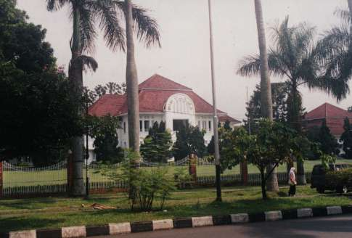
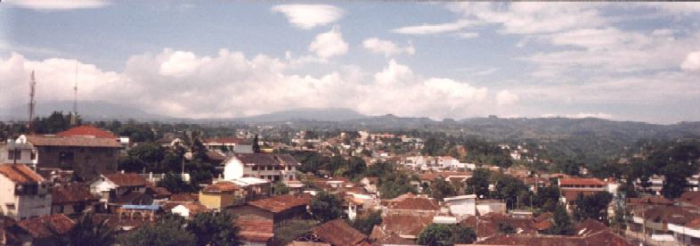
Off to Jakarta in Indonesia last Sunday on a 0930 Cathay flight. On arrival, I was driven by Pearson (the publisher) people to the inland city of Bandung, which took about three hours on a good toll highway. Occasional very heavy rain during the trip. Bandung is a smaller town (population about 2 million) surrounded by a volcanic range of mountains founded by the Dutch in 1810 and was to be made their capital of Indonesia until WWII upset their plans. It is quite a nice place with many tree-lined streets. Checked into an old Dutch-style hotel, which I quite liked. Dinner that evening was in a Javanese-style restaurant, with typical Javanese food. I was worried about eating as I knew they like very hot food, but fortunately, the hot spices are most often separated and placed in separate dishes and added as desired. In the restaurant there was a waiter that reminder me of Gavin in the way he looked (e.g. haircut, build), stood, moved and in his politeness!

The next morning I was up at 6 am, which seems early but in HK it would be about 8 am as Indonesia has a very odd time zone. The Sun is well up by that time and schools start at 7 am! After breakfast, we walked around to another hotel where the workshops were to be held. There were about 100 participants including 48 teachers for Science (instead of the anticipated 60), others for English and some school principals. Things started nearly one hour late with the obligatory speeches that fortunately were shorter than expected so we made up some time. During the day, I had two sessions of about 90 minutes each. I talked about using English to teach Science, some ideas on teaching and learning and learning from educational psychology followed by the books and how such ideas were used in their design. The sessions went very well. The second session was actually translated, as the English standard of some participants was not good, which is not a good sign if they have to teach in the medium of English. In fact, as I was to discover the next day, the English standard of many students is much better than that of their teachers. That evening we all had dinner in a restaurant, which is part of a large bakery shop, mainly because most of the Pearson staff wanted to buy bakery products to take back to Singapore with them.
On Tuesday morning, I visited two schools and talked with students in two classes. I also used one of the Science books to do a bit of teaching. This is when I discovered that the standard of English of the students was not bad and for some was very good. The school buildings were old but OK and in one school I visited, all students had a computer under their desks! The teachers who were watching while I spoke and taught the classes liked what they saw and heard and could see how the theory I was talking about in the workshops could be put into practice. So much in fact, that I will probably be going back again in July (when their school year begins) to do a similar thing in perhaps 10 schools.

At 10 am, after the school visits, I left for another three-hour drive to the airport in Jakarta for the 1450 flight back to HK. This time I was the only passenger in the car compared with the five of us for the trip down. I enjoyed my stay in Bandung very much and the people there are very hospitable.
In Hong Kong, there is a lot of flu about. Several young children have died from flu-like illnesses. However, their deaths were not due to the H5N1 (‘bird flu’) virus strain. People are starting to wear facemasks again, not seen since the SARS outbreak back in 2003. Kindergartens and primary schools have been closed early for the Easter holidays due to spread of flu in them. In the POW Hospital, a young woman (a CUHK student I think) died following a CT scan (i.e. Computed Tomography scan that creates a 3-D image of a cross-section of parts of the body from a series of X-rays); the reason is not yet known.

I went for a run yesterday, the first exercise for over a week. Went from Tai Po over to and around the Shing Mun reservoir, taking 2 hr 39 minutes, two minutes slower than last year and one minute slower than the year before.

A lot of Rugby this weekend. The final Six Nations matched were played, with Wales beating France 29-12 and, against all the odds given their recent miserable performances, winning all their matches and so becoming the champions (in picture, Wales in red.) The Crusaders are still top of the Super 14 competition with 5 wins out of 5 games with a 55-7 victory over a SA team on Saturday.
Nadine, following your e-mail, I looked up the website on how the dolphin rescued the stranded whales on the beach near Gisborne (actually about 50 miles South). Saw it again several times later on various TV news reports. Very interesting.
You have also probably learnt about the riots and chaos in Tibet. China says 10 people have been killed, but sources that are more credible put the figure at over 100. There is a lot of built-up resentment amongst ethnic Tibetans since China sent in troops in 1950, resulting some years later in the flight of the Dali Lama and many others to India. This kind of trouble is the last thing China wanted in this Olympic year, especially knowing that the entire world is watching to see what action they will take. Still, as many have said, if there is a good time to protest against China, then this is the time to do it. So Nadine, is Tibet still on your list of places to visit? Given the problems in the world, you may not be able to go anywhere new!!
That’s about it for now.

Cheers.

